Anthony Simon

SD7 25 Apr 2020

Sprint Execution & Review

Submit: 1.) Daily screenshots Each day take a screenshot of the Kanban issue board. At the end of the sprint, submit your daily screenshots.

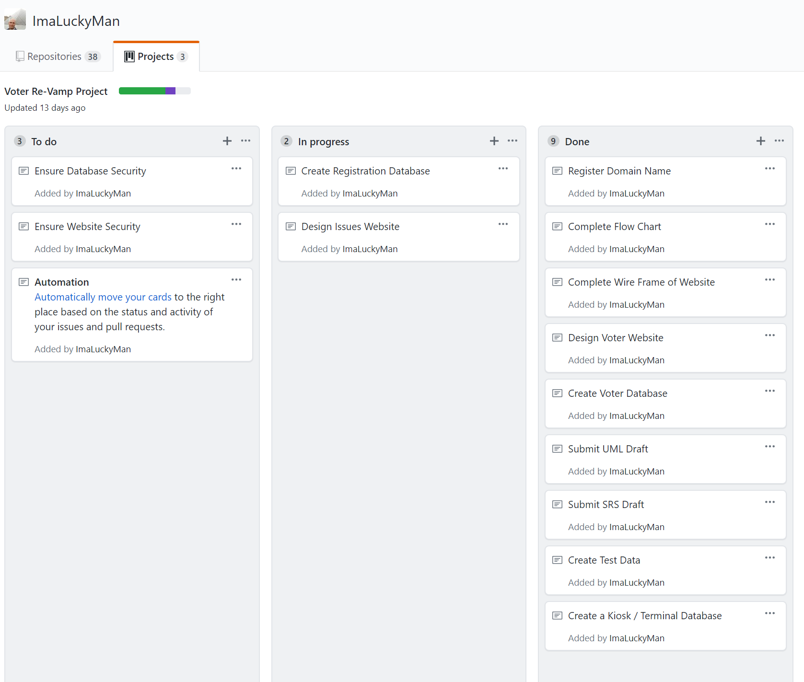

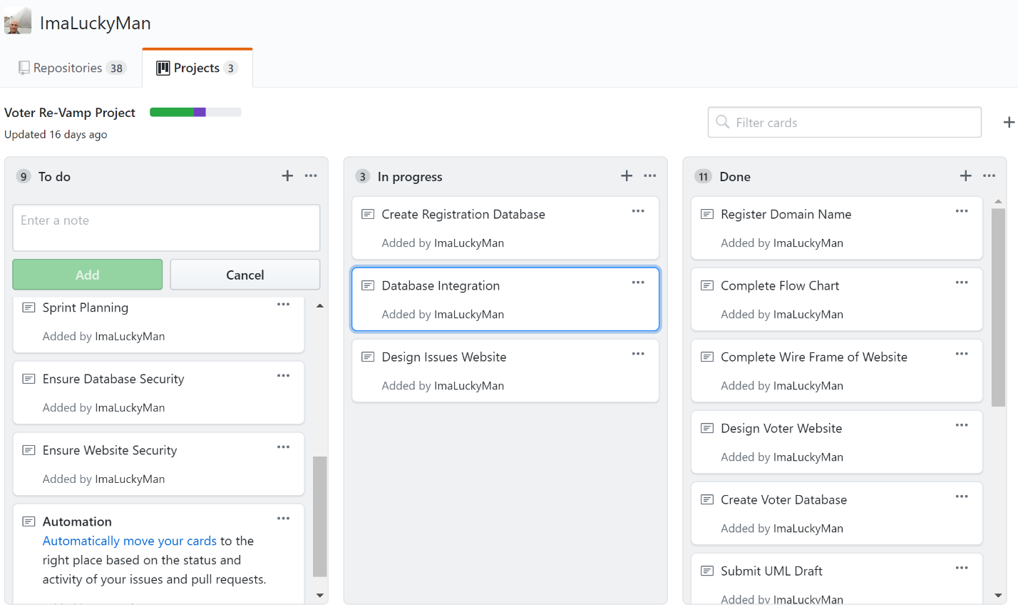

2.) Burndown chart (what is a burndown chart?) There are many sprint tracking tools available. Github is convenient because you can track all elements of your project together, but it doesn't support burndown charts yet. Use any tool to show what a burndown chart of your sprint might look like.

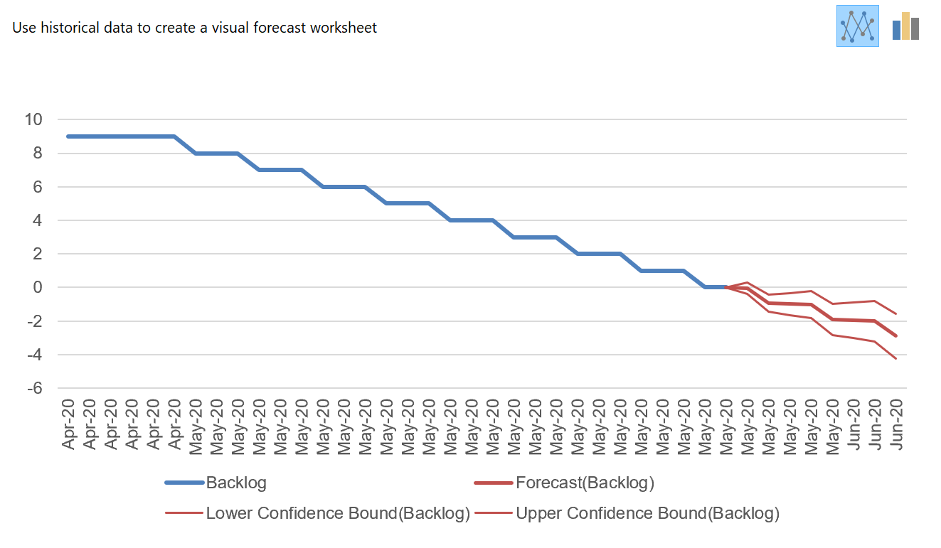

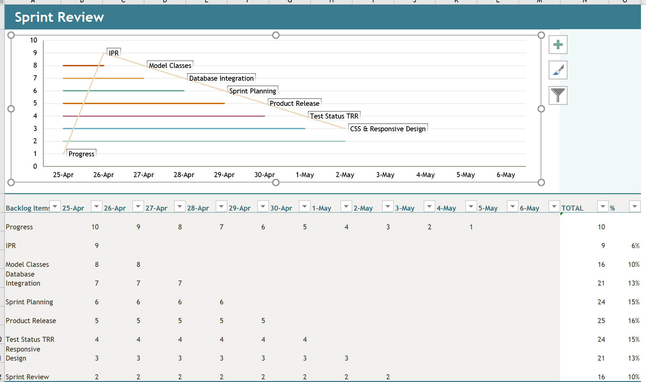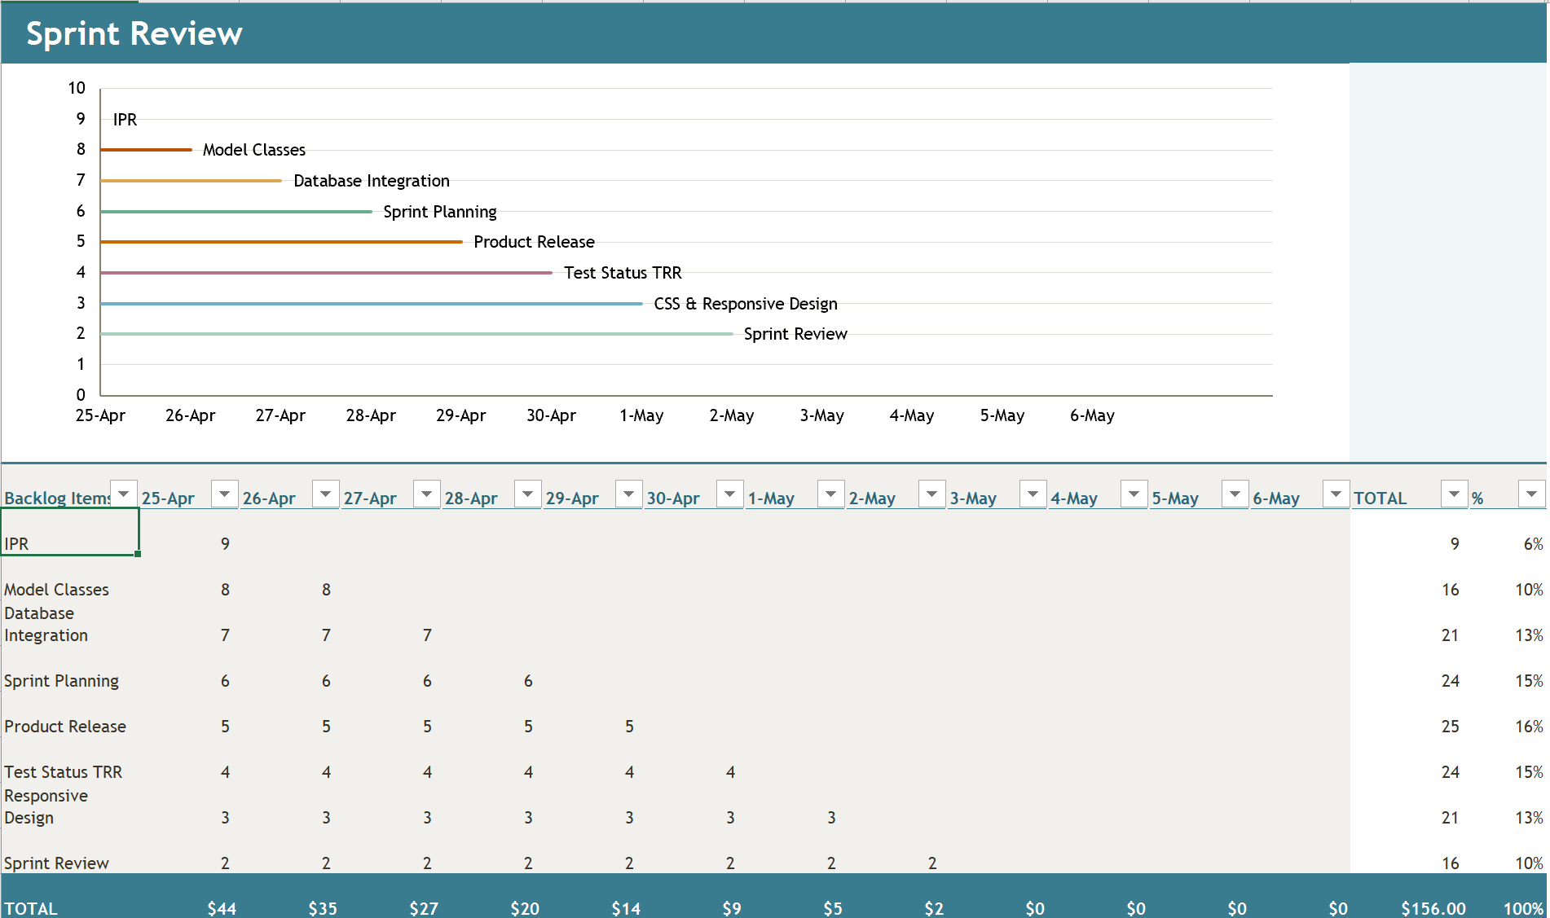

3.) Sprint Review Answer the following:

* Did you complete all items in your sprint plan?

No – My sprint plan is still a work in progress

* What is your sprint deliverable? (shippable product(s))

Completed items as well as those still in progress and projected due dates to keep on track

* Did you have any task volatility, and what was the cause?

Yes, if tasks are not completed on schedule they will not be ready by the due dates or end of course

* What would you do differently knowing what you know now?

Make a better plan from the beginning now having a better idea of what is involved in the planning process.

4.) (Next) Sprint Plan Create another 'project' (may be named "sprint 2") and add items from your prioritized backlog issues. Attach a screenshot of the new Kanban board (sprint plan)

